**OUTPUTS**

|  |  |
| --- | --- |
| Date | 26 June 2025 |
| Team ID | LTVIP2025TMID30678 |
| Project Name | To Supply Leftover Food To Poor |
| College Name | Aditya collage of Engineering and Technology |
| Team members | 1)Sadi ramana (Leader) – 22MH1A04D6   * [Ramanarebel69@gmail.com](mailto:Ramanarebel69@gmail.com)   2)Sravani kasireddy (Documentation developer and opearator ) - 23MHA0412   * [Sravanikasireddy850@gmail.com](mailto:Sravanikasireddy850@gmail.com) |

The outputs of this project come in the form of:

**A.1.CUSTOM REPORT:**

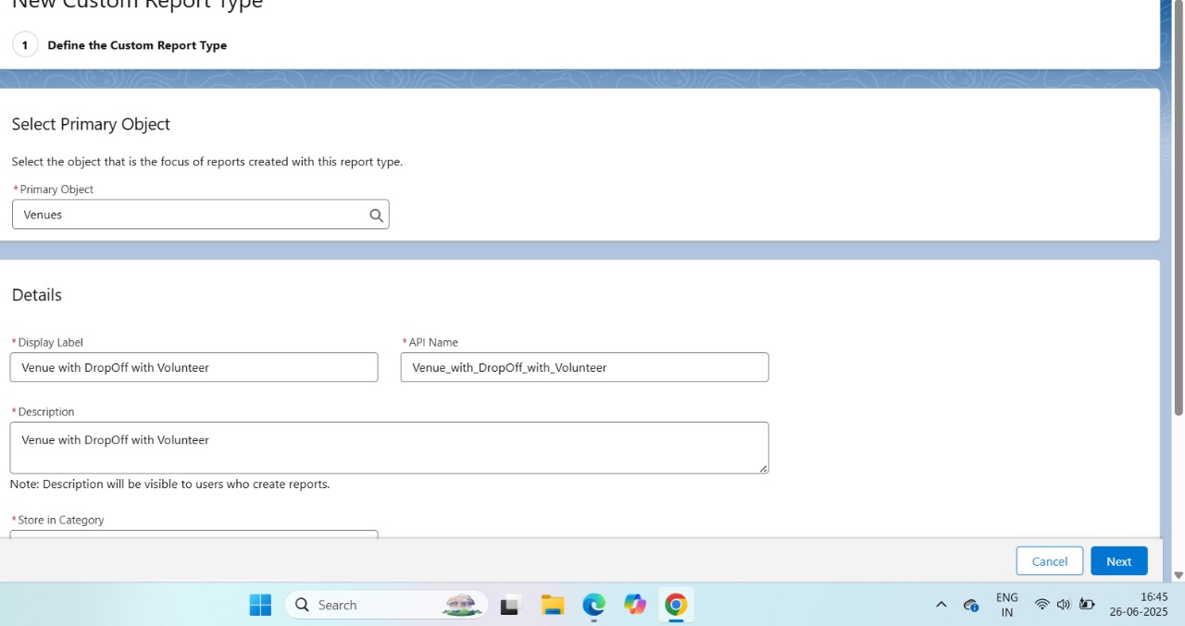

**2.CUSTOM REPORT:**

**Flow:**

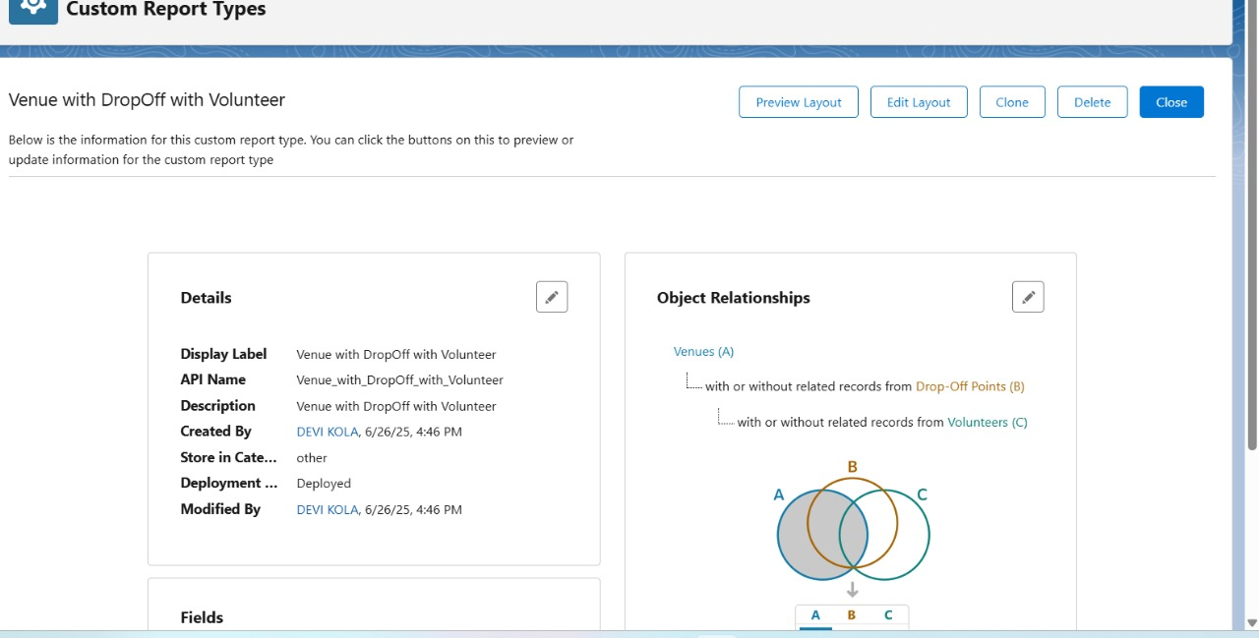

**DASHBOARDS:**

**B.Dashboard 1:**

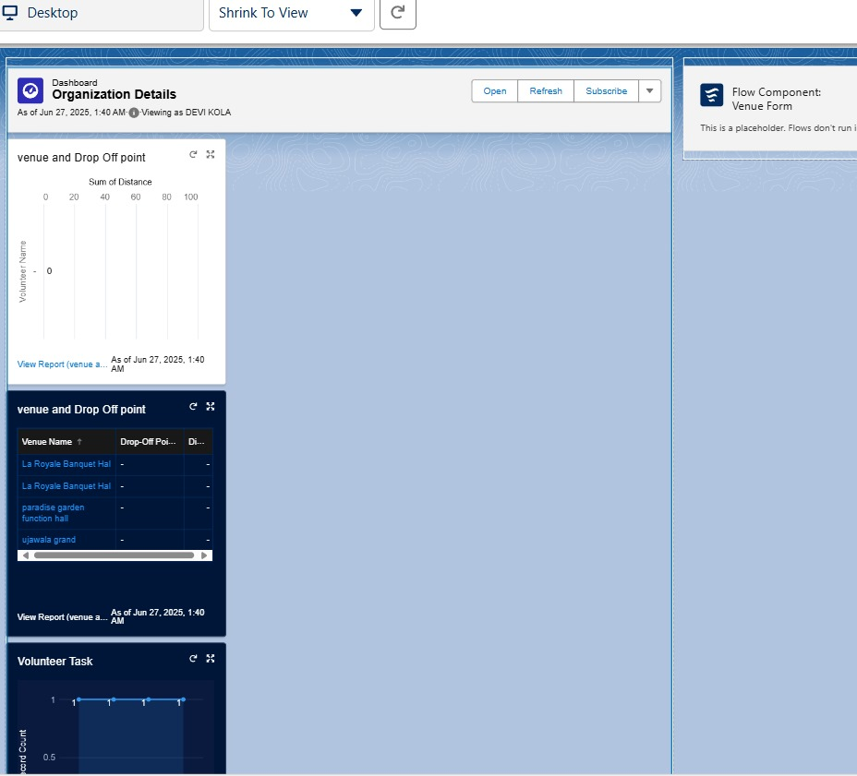

**Dashboard 2:**

